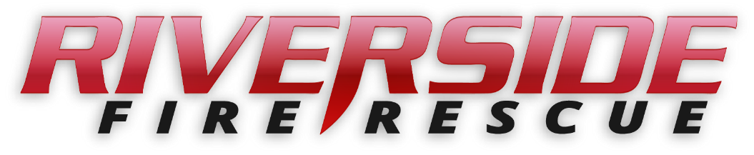

Pierce County Fire Protection District No. 14

Commissioners Meeting

November 25, 2024, Station74

**In Attendance:** Chief Kira Thirkield, Commissioner William Shearer (via remote access), Commissioner Jerry Sandberg, Commissioner Peter Allison, FF Koll Ford, FF Titus Leaman and Secretary Pat Shandrow.

Guest Brent Adams

Commissioner Shearer opened the meeting with the flag salute at 6:30 p.m.

The minutes of the November 12, 2024 Regular Board Meeting were approved as presented.

**Vouchers:** Voucher list was reviewed, approved and attached.

**Financial Report:** The Financial Report was tabled until the next meeting.

**Old Business:**

1. NONE

**New Business:**

1. None

**Citizen Comments:** None scheduled.

**Good of the Order**

* Remaining updates to the furnace in the station will be $11,000
* We will have 10 or 11 volunteers attending the academy starting in Buckley in January. Not 8 as previously reported.
* Thanksgiving Pot Luck and Cord Hole Tournment will be November 26, 6:30 – 9:00.
* South Sound 911, Chief Tirkield sat in on dispatch and Chiefs meeting.
* We have stopped using Olympic and are using Central Pierce for medic transports. With the closest forces agreement with Central Pierce which includes Orting, Graham and South Pierce, the closest unit to respond will go live January 1.

With no further business to come before the Board, the meeting adjourned at

6:43 pm.

____________________________

William Shearer, Commissioner

____________________________

Gerald Sandberg, Commissioner ATTEST:

____________________________ ________________________

Peter Allision, Commissioner Pat Shandrow, District Secretary