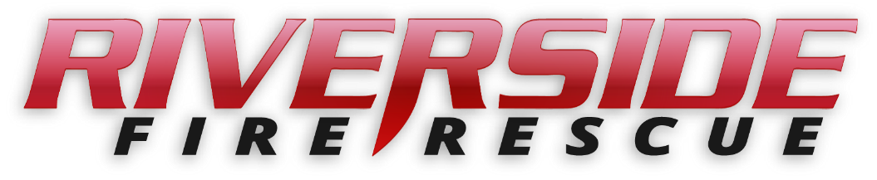

Pierce County Fire Protection District No. 14

Commissioners Meeting

November 12, 2024, Station74

**In Attendance:** Chief Kira Thirkield, Commissioner William Shearer, Commissioner Jerry Sandberg, Commissioner Peter Allison and Secretary Pat Shandrow.

Commissioner Shearer opened the meeting with the flag salute at 6:40 p.m.

The minutes of the October 28, 2024 Regular Board Meeting were approved as presented.

**Vouchers:** Voucher list was reviewed, approved and attached.

**Chief’s Report:** The Chief’s Report for October was presented, reviewed and attached.

**Old Business:**

1. Resolution 2024-403 - Resolution 2024-403 – A resolution of the Board of Fire Commissioners for Pierce County Fire Protection District No.14 authorizing an increase in the regular property tax to be collected in the 2025 tax year was reviewed. A motion was made and seconded to approve Resolution 2024-403. Motion carried unanimously.
2. Resolution 2024-404 – A resolution of the Board of Fire Commissioners for Pierce County Fire Protection District No.14 authorizing an increase in the EMS property tax to be collected in the 2025 tax year was reviewed. A motion was made and seconded to approve Resolution 2024-404. Motion carried unanimously.
3. Resolution 2024-405 – A resolution of the Board of Fire Commissioners for Pierce County Fire Protection District No.14 approving the 2025 budget was reviewed. A motion was made and seconded to approve Resolution 2025-405. Motion carried unanimously.

**New Business:**

1. We have received a letter of engagement from the Washington State Auditor’s Office informing us that they will be holding an audit for years ending December 31, for 2021, 2022, and 2023.

**Citizen Comments:** None scheduled.

**Good of the Order**

* Academy updates: All 13 of our recruits have passed their Live Fire Testing. They also all passed their Written Test. Practical skills testing will be done this coming Saturday, November 16.
* The academy starting in Buckley in January will have room for 8 applicants from District 14.
* Chief Morrow of Central Pierce liked our station during his recent visit on the 24th of October. On the 8th of November he and Chief Thirkield went and met with the Emergency Management Division for the Puyallup Tribe led by Dennis Young.
* New Fire Engine update: A pre-construction trip to Appleton Wisconsin is tentatively scheduled for October in 2025 and a final inspection trip tentatively in May of 2026.

With no further business to come before the Board, the meeting adjourned at

7:33 pm.

____________________________

William Shearer, Commissioner

____________________________

Gerald Sandberg, Commissioner ATTEST:

____________________________ ________________________

Peter Allision, Commissioner Pat Shandrow, District Secretary