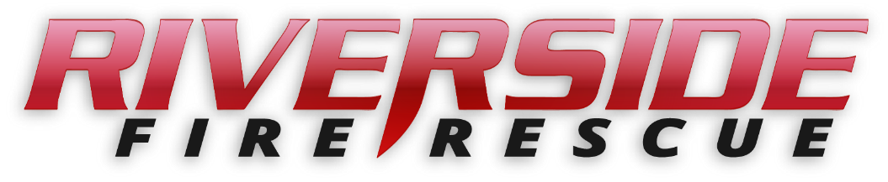

Pierce County Fire Protection District No. 14

Commissioners Meeting

January 27, 2025, Station74

**In Attendance:** Chief Kira Thirkield, Commissioner William Shearer, Commissioner Jerry Sandberg, Commissioner Peter Allison and Secretary Pat Shandrow.

Commissioner Shearer opened the meeting with the flag salute at 6:30 p.m.

The minutes of the January 13, 2025 Regular Board Meeting were approved as presented.

**Vouchers:** Voucher list was reviewed, approved and attached.

**Financial Report:** The Financial Report was presented, reviewed and attached.

**Old Business:**

1. None

**New Business:**

1. The audit has been done and will be completed with an Audit Exit Conference via Microsoft Teams on Wednesday January 29, 2025 at 3:00 pm.

**Citizen Comments:** None scheduled.

**Good of the Order**

* Amy Devine is working with the Washington State Department of Health to start a program for “leave at home” doses of NARCAN.
* Amy Devine is working with the Red Cross to continue a previous program for free Smoke Detectors for distribution within our District.
* W-2 ‘s will be mailed soon.
* Kira will be meeting with a mechanic who is a current mechanic for West Pierce Garage. He is a fully certified union mechanic who will be opening his own shop soon. This would be a good source for maintaining our equipment as we are finding Central Pierce is too busy to service ours.
* We are projected to go Live in March with the Closet Forces Agreement.
* The Annual Awards Banquet is being planned for March 1 at the Daffodil Bowling Alley.

With no further business to come before the Board, the meeting adjourned at

7:26 pm.

____________________________

William Shearer, Commissioner

____________________________

Gerald Sandberg, Commissioner ATTEST:

____________________________ ________________________

Peter Allision, Commissioner Pat Shandrow, District Secretary