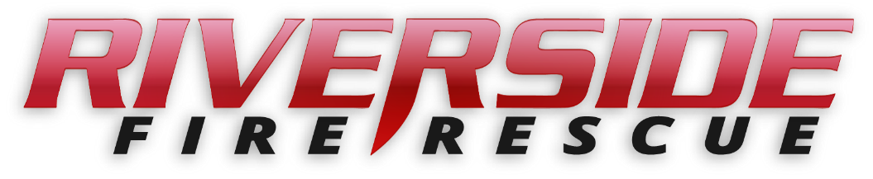

Pierce County Fire Protection District No. 14
Commissioners Meeting
July 24, 2023 Station74

In Attendance: Chief Kira Thirkield, Commissioner Peter Allison, Commissioner William Shearer, Commissioner Gerald Sandberg, FF Andrew Torgerson,
FF Katie Walther and Secretary Pat Shandrow.

Guests: None
Commissioner Allison opened the meeting at 6:30 p.m.

The minutes of the July 10, 2023 Regular Board Meeting were approved as presented.
Citizen Comments: None

Vouchers: Voucher list was reviewed, approved and attached.

Financial Report: The Financial Report was presented, reviewed and attached.

Old Business:
- Staffing – The updated Employment Service Agreement was presented to the Commissioners for final review. Following approval, the service contract to hire Alex Stopsack as full time Lieutenant was unanimously approved to be signed by Chief Thirkield.
- New Fire Engine: Chief Thirkield made an announcement that the Puyallup Tribe has approved our recent grant request for partial funding of our new fire engine. At present, we do not know the amount. This will be revealed at the check presentation, by the Tribal Council, on August 8 at 2:00 pm at the I-5 Emerald Queen Casino. We are very excited about being approved for this grant.

New Business:
A: Resolution 2023-390 – Resolution providing for the submission of Levy (General Election – Provisional) A resolution of the Board of Commissioners of Pierce County Fire Protection District No. 14 providing for the submission of levy to the qualified electors of The District, at an election to be held within the District, on November 7, 2023 in conjunction with the State General Election to be held on the same date. This proposition shall not be submitted to the voters if the levy authorized by Resolution No 2023-388 is approved by the voters at the primary election held on August 1, 2023. This resolution was reviewed by the Commissioners and a motion made to approve. Motion was approved unanimously.

Good of the Order

- We are now expecting to have 25 to 27 recruits attend our upcoming in-house fire academy we are hosting.
- Chief Thirkield will follow up with Brian Snure for more information about his seminar for required training.
- Chief Thirkield has received revised/updated contracts for Chief and Lieutenant (Dean’s) position from Brian Snure for review.
- Dennis with the Puyallup Tribe Public Safety Division would like Chief Thirkield and perhaps one or two of the Commissioners to attend a Tribal Council meeting to help build a better Tribal Government relationship. This would be in a month or two as it takes time to be put on the Tribal Agenda
- We will be standing by at Chief Leschi School for National Night out on Tuesday August 1 from 4:30 TO 9:00 PM.
- Commissioners may occasionally need to schedule remote meeting access in the near future due to being out of town.

With no further business to come before the Board, the meeting adjourned at
7:25 pm.

____________________________
Peter Allison, Commissioner

____________________________
William Shearer, Commissioner ATTEST:

____________________________ ________________________
Gerald Sandberg, Commissioner Pat Shandrow, District Secretary

