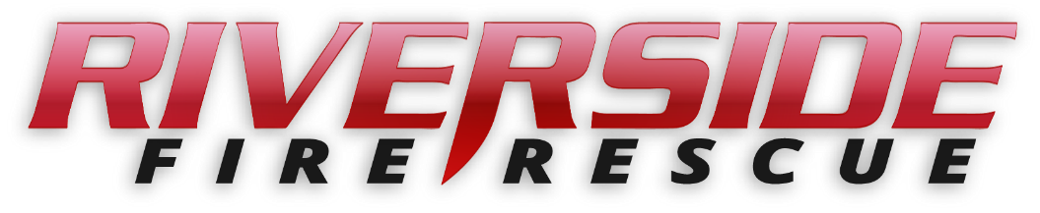

Pierce County Fire Protection District No. 14
Commissioners Meeting
July 10, 2023 Station74

In Attendance: Chief Kira Thirkield, Commissioner Peter Allison, Commissioner William Shearer, Commissioner Gerald Sandberg and Secretary Pat Shandrow.

Guests: None
Commissioner Allison opened the meeting at 6:40 p.m.

The minutes of the June 26, 2023 Regular Board Meeting were approved as presented.
Citizen Comments: None

Vouchers: Voucher list was reviewed, approved and attached.

Chief’s Report: The Chief’s Report was presented, reviewed and attached.

Old Business:
- Staffing – The updated Employment Agreement presented to the Commissioners for review at the June 26, 2023 was discussed. A few changes in the wording was recommended to be more understandable and explicit. Edits will be made and the revised contract will be presented at the next meeting.
- New Fire Engine: A discussion was had about the funding for the new fire engine and some of its features.

New Business:
A: Resolution 2023-389 – A resolution of the Board of Commissioners for Pierce County Fire District No. 14 authorizing and directing that a certain account or accounts for cost recovery fees and charges shall be written off as uncollectable. After review a motion was made by the Commissioners to approve. The motion was approved unanimously.

Good of the Order
- We currently have two recruits attending the South Pierce Academy.

- We expect to have 20 to 25 recruits attending our upcoming in-house fire academy we are hosting.

- The Drainage district held their meeting at PCFD14 the evening of June 29 at 6:00 pm. Commissioner Sandberg attended the meeting.

With no further business to come before the Board, the meeting adjourned at
7:57 pm.

____________________________
Peter Allison, Commissioner

____________________________
William Shearer, Commissioner ATTEST:

____________________________ ________________________
Gerald Sandberg, Commissioner Pat Shandrow, District Secretary

