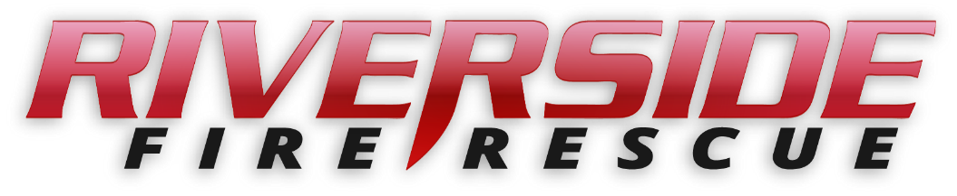

Pierce County Fire Protection District No. 14
Commissioners Meeting
March 13, 2023 Station74

In Attendance: Captain KP George, Commissioner Peter Allison, Commissioner Gerald Sandberg, Commissioner William Shearer, FF Jennifer Alberg and Secretary Shandrow. Chief Thirkield was excused.

Commissioner Sandberg opened the meeting at 6:30 p.m.

The minutes of the February 13, 2023 Regular Board Meeting were approved as read.
Citizen Comments: None

Vouchers: Voucher list was reviewed, approved and attached.

Chief’s Report: The Chief’s Report was tabled until the March 27 meeting.

Old Business:

- Chief – Annual Review. The completion of the Annual Review for Chief Thirkield was tabled until the March 27 Commissioner meeting.
New Business:

- None
Good of the Order

- The Firefighters Association is planning to hold their Banquet at the Tacoma Rainiers baseball game at Cheney Stadium on April 7, 2023. The game starts at 7:05 pm. More details to follow.

- Attaching a heavy duty chain to the Gator when relocated in the new shed was discussed.

- Driver Training protocols was also discussed.

With no further business to come before the Board, the meeting adjourned at
7:15 p.m.

____________________________
Peter Allison, Commissioner

____________________________
William Shearer, Commissioner ATTEST:

____________________________ ________________________
Gerald Sandberg, Commissioner Pat Shandrow, District Secretary

