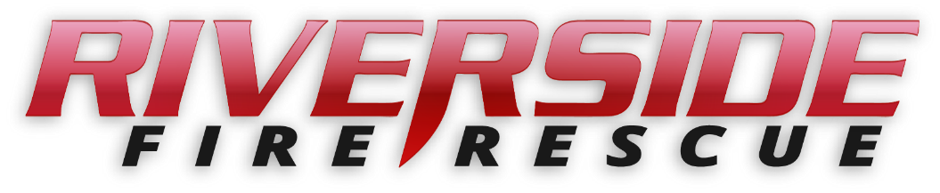

Pierce County Fire Protection District No. 14
Commissioners Meeting February 24, 2020

In Attendance: Chief Kira Thirkield, Commissioner Peter Allison, Commissioner Jerry Sandberg, Commissioner John Campbell, FF Austin Ross, FF Joseph Brinkis and Secretary Pat Shandrow.

Commissioner Allison opened the meeting with the pledge of allegiance at 6:30 p.m.

The minutes of the February 10, 2020 Regular Board Meeting were approved as presented.
Citizen Comments: None.
Vouchers: Voucher list was reviewed and approved and attached.

Financial Report: The Financial Report was presented reviewed and attached.
The Regular Meeting recessed for a Board of Volunteer Firefighters meeting at 6:43 pm.
Regular meeting reconvened at 6:50

Old Business:

- SOP Rewrite Project: Nothing new to report.
- The JBLM Agreement, which had been given to the Commissioners at the February 10 meeting for review, was unanimously approved.

New Business:

- None

Good of the Order:
- The Awards Banquet was held on February 18 at the Rock and was enjoyed by all in attendance. The following awards were presented:
Officer of the Year: Lt. Michael Cramer
Firefighter of the Year: Ryan Schuh
Rookie of the Year Trevor Finneseth
Most Reliable: Kale Bartroff
Most Dedicated: Kale Bartroff
Chief’s Award: Chris Leppell

With no further business to come before the Board, the meeting adjourned at 7:02. p.m.

____________________________
Peter Allison,

____________________________
Gerald Sandberg, Commissioner ATTEST:

____________________________ ________________________
John Campbell, Commissioner Pat Shandrow, District Secretary

