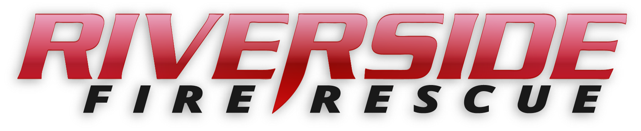

Pierce County Fire Protection District No. 14

Commissioners Meeting September 9, 2019

**In Attendance:** Commissioner John Campbell, Commissioner Jerry Sandberg, Fire Chief Kira Thirkield and Secretary Pat Shandrow.

Commissioner Allison was excused.

Commissioner Campbell opened the meeting with the pledge of allegiance at 6:30 p.m.

The minutes of the August 26, 2019 Regular Board Meeting were approved as presented.

**Citizen Comments:** None

**Vouchers:** Voucher list was reviewed, approved and attached.

**Chief’s Report:** The Chief’s Report was presented reviewed and attached.

The Regular Meeting recessed for a Board of Volunteer Firefighters meeting at 7:00 pm.

Board for Volunteer Firefighters Meeting began at 7:00 pm.

Board for Volunteer Firefighters Meeting ended at 7:03 pm.

Regular meeting reconvened at 7:04 pm.

**Old Business:**

1. SOP Rewrite Project: 1000 Series policies were discussed by the Commissioners. One policy needs to be revised and one new policy needs to be added. All policy series continue to be reviewed.
2. Hazard Mitigation Plan: Ongoing.
3. Puget Sound Fire Consortium. Chief will sign on behalf of the Commissioners at the next meeting.
4. Insurance Assessment: We have received a quote from Nicholson & Associates Insurance LLC. Their rate is approximately half of what we are currently paying for insurance. Current contract was originally signed in 2010. We are still waiting on more information from the CIAW Board on being allowed to discontinuing insurance coverage from their company. Their Board will be meeting on October 18.

**New Business:**

**None**

The regular meeting was recessed to go into a 15 minute Executive Session per RCW 42.30.100 (1)(g) To evaluate the qualifications of an applicant for public employment or to review the performance of a public employee.

Executive Session began at 7:35 p.m.

Executive Session ended at 7:48 p.m.

The Regular meeting reconvened at 7:48 p.m.

Commissioner Campbell stated there was no business to follow from the Executive Session.

**Good of the Order:**

* Discussion was had on the need for Fire Engines to be chalked or not on flat ground when parked.
* Chief Thirkield will be meeting with Kathy Hale on September 10 to begin discussion of the budget for 2020.
* Painting of Station is complete with the exception of some minor touch-ups. Chris Leppell has done a good job of organizing and getting this job done.

With no further business to come before the Board, the meeting adjourned at 8:00. p.m.

____________________________

John Campbell, Chair

____________________________

Peter Allison, Commissioner ATTEST:

____________________________ ________________________

Gerald Sandberg, Commissioner Pat Shandrow, District Secretary