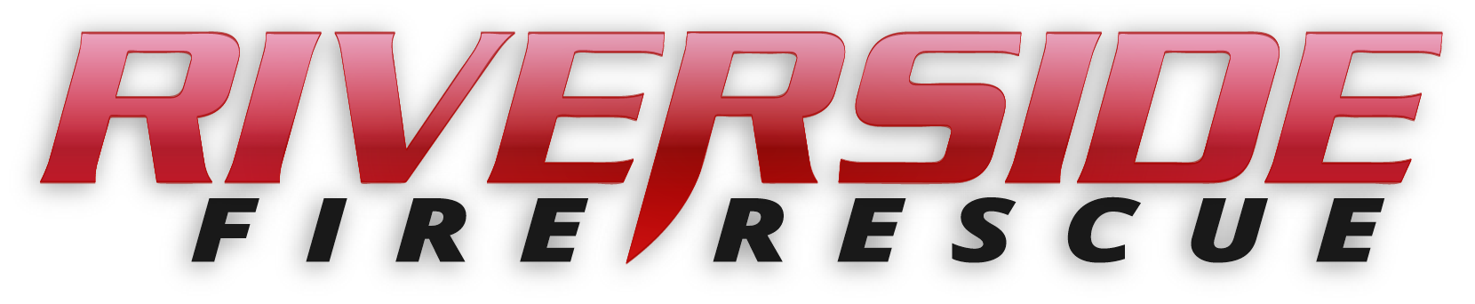

Pierce County Fire Protection District No. 14
Commissioners Meeting July 8, 2019

In Attendance: Commissioner John Campbell, Commissioner Peter Allison, Commissioner Jerry Sandberg, Fire Chief Kira Thirkield, and Secretary Pat Shandrow.

Commissioner Campbell opened the meeting with the pledge of allegiance at 6:30 p.m.

The minutes of the June 24, 2019 Regular Board Meeting were approved as presented.
Citizen Comments: None
Vouchers: Voucher list was reviewed, approved and attached.

Chief’s Report: The Chief’s Report was presented reviewed and attached.

Old Business:

- SOP Rewrite Project: 1000 Series still under review by the Commissioners. Work is continuing on the 2000 Series.
- Hazard Mitigation Plan: Ongoing. A meeting is scheduled on Tuesday, July 9, 2019 with Pierce County Department of Emergency Management (DEM).

New Business:
None

Good of the Order:

- Fourth of July went well. We only had three calls which all ended up be nothing.
- Annual BBQ and Hot Dog Eating Contest was held on Sunday, June 30. The winner was Trevor Finneseth, eating ten hotdogs in ten minutes.

With no further business to come before the Board, the meeting adjourned at 7:09. p.m.

____________________________
John Campbell, Chair

____________________________
Peter Allison, Commissioner ATTEST:

____________________________ ________________________
Gerald Sandberg, Commissioner Pat Shandrow, District Secretary

