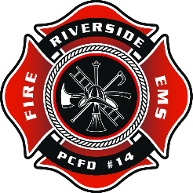
Riverside Fire & Rescue
Pierce County Fire Protection District No. 14
4114 56TH AVE E • PUYALLUP, WA 98371 • (253) 922-5644 • (253) 252-7941
www.piercefire14.org

The Board of Commissioners of Pierce County Fire District 14 have deemed certain items to be no longer used or needed and therefore surplus. The items listed below are available for sealed bid:

E2500 Honda Generator
Condition: Old, but well maintained and working.
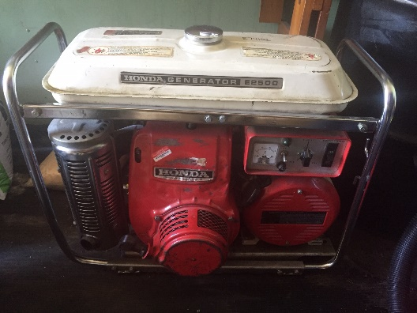

Stihl MS 290 Chainsaw
Condition: Old, but well maintained and working.
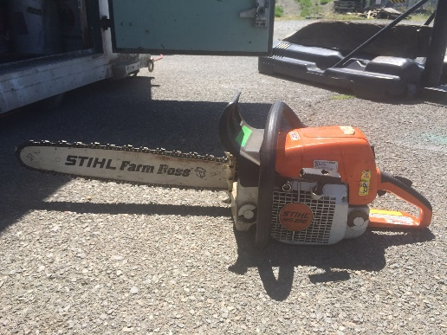
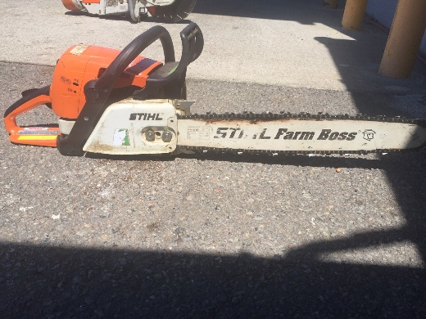

Stihl TS 350 Super Cut-Off Saw
Condition: Old, but well maintained and working.
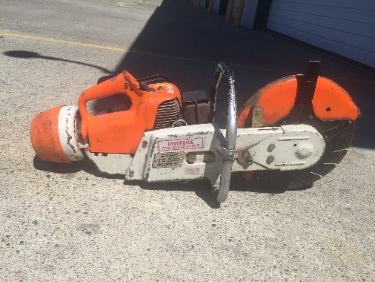
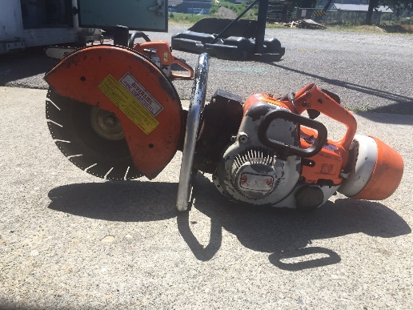

2008 AK-80 Air-Kwik Air Powered Portable Water Pump
Description: 80 Gallon water pump operated by air. Fits great in the back of a pick-up truck.
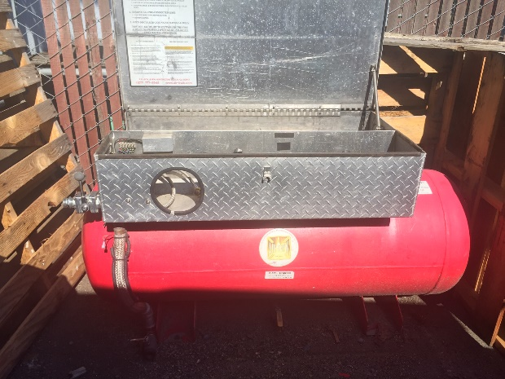
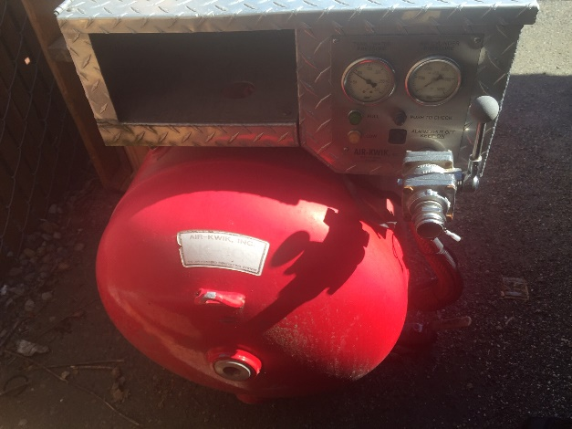
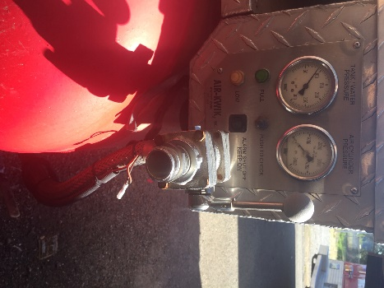
Condition: Good Operating Order, Rarely Used.

Please DO NOT call or email with questions.

Viewing of equipment and in-person questions will be allowed only Friday July 26th 2019 from 4:00pm-6:00pm at Riverside Fire, please do not call ahead of time.

Bids must be sealed and mailed or delivered directly to Riverside Fire no later than 5:00pm July 31st 2019.

Bids will be reviewed, and the highest bidder will be notified within 1 week. All items must be paid for and picked up within 72 hours of notification or the next highest bid will be awarded.

4114 56th Ave E
Puyallup, WA 98371

