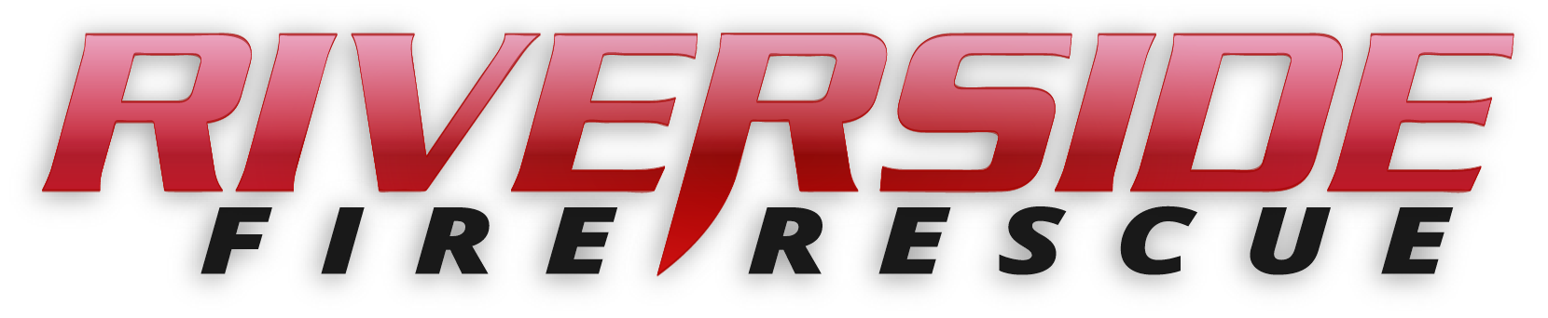
Pierce County Fire Protection District No. 14
Commissioners Meeting March 11, 2019

In Attendance: Commissioner Peter Allison, Commissioner John Campbell, Commissioner Jerry Sandberg, Fire Chief Kira Thirkield and Secretary Pat Shandrow.

Commissioner Campbell opened the meeting with the pledge of allegiance at 6:30 p.m.

The minutes of the February 25, 2019 Regular Board Meeting were approved as presented.
Citizen Comments: None

Vouchers: Voucher list was reviewed, approved and attached.

Chief’s Report: The Chief’s Report was presented, reviewed and attached.

Old Business:

- SOP Rewrite Project: Amy Olson is working on this project. Coming along at a good pace.
- Hazard Mitigation Plan: Ongoing

New Business:

- System Design Audit: Chief Thirkield spent 3 plus hours auditing 10 different accounts at System Design, the company that does our transport billing. The audit went very will. They have a good system in process.

- Department of Natural Resources Annual Agreement: DNR agreement was presented to the Commissioners for review. This an inter local agreement to use each others resources in regards to wild land fire.

Good of the Order:.

- Refresher training and been completed and new firefighters are still doing their training for their wildland firefighter Red Card.

- Pierce County Fire Chiefs Association asked if Chief Thirkield would be the BLS representative for Pierce County Fire Chiefs.

- BC Brent Dubay is attending a Training management course at the National Fire Academy in Emmitsberg MD.

With no further business to come before the Board, the meeting adjourned at 7:26. p.m.

____________________________
John Campbell, Chair

____________________________
Peter Allison, Commissioner ATTEST:

____________________________ _____________________________
Jerry Sandberg, Commissioner Pat Shandrow, District Secretary

