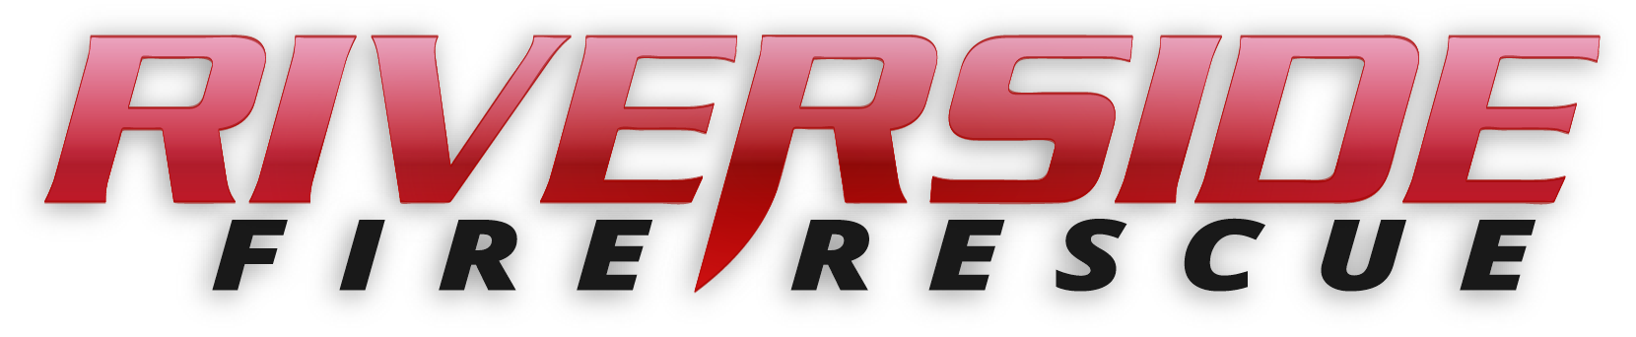
Pierce County Fire Protection District No. 14
Commissioners Meeting April 8, 2019

In Attendance: Commissioner Peter Allison, Commissioner John Campbell, Commissioner Jerry Sandberg, Fire Chief Kira Thirkield and Secretary Pat Shandrow.

Commissioner Campbell opened the meeting with the pledge of allegiance at 6:30 p.m.

The minutes of the March 25, 2019 Regular Board Meeting were approved as presented.
Citizen Comments: None

Vouchers: Voucher list was reviewed, approved and attached.

Chief’s Report: The Chief’s Report was presented, reviewed and attached.

Financial Report(s):
The February Financial Report tabled from the previous meeting was presented, reviewed and attached.

The Financial Report for March was presented, reviewed and attached.

Old Business:

- SOP Rewrite Project: Final first draft of 1000 series was presented to the Commissioners for review.
- Hazard Mitigation Plan: Ongoing – No update at this time.

New Business:

- None

Good of the Order:

- There was a residential Fire in Majestic. This was a room and content fire. Resident was evacuated, fire was put out and home saved.
- Tender is in for maintenance and annual testing.
- All seven firefighters who attended the IFSAC Firefighter II training passed their practical testing and are awaiting written test results.

With no further business to come before the Board, the meeting adjourned at 7:10. p.m.

____________________________
John Campbell, Chair

____________________________
Peter Allison, Commissioner ATTEST:

____________________________ _____________________________
Gerald Sandberg, Commissioner Pat Shandrow, District Secretary

