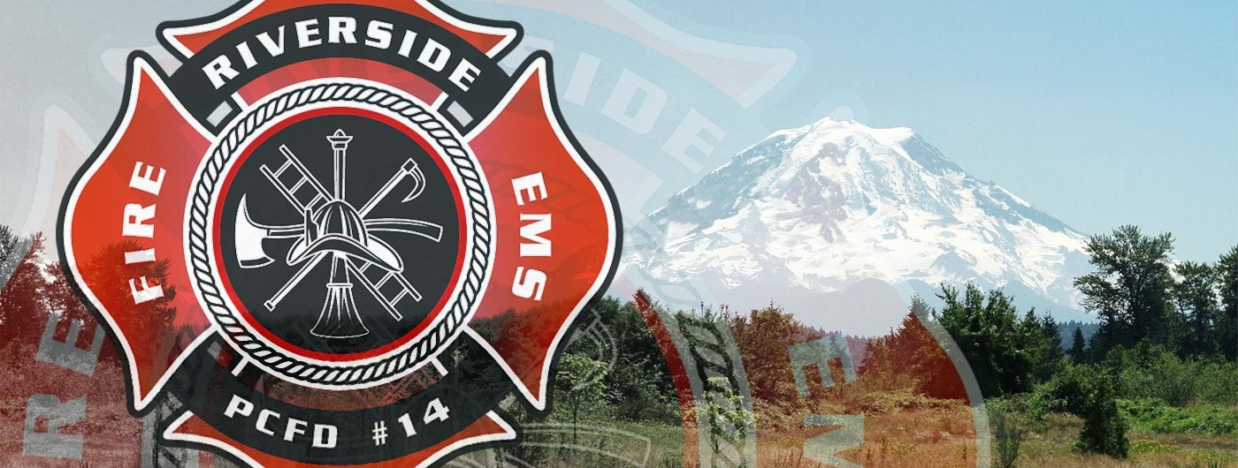

Professionalism: “The Competence or Skill expected of a professional.”

When you sign this form you agree to maintain a professional attitude and discipline to skills and competence to understand and successfully perform this profession. Being a firefighter is not a part time job or a hobby. Volunteer or career, this profession requires your dedication and commitment to training and upholding the image of what a firefighter is.

Professionalism means –

1. Attitude. Always have a positive attitude, and be grateful for the opportunity to be a member of the fire service. Never show citizens or others that you are not thankful to be out there assisting the public in any capacity. In our job duties, we must anticipate that we engage citizens and other city and county employees at times and incidents that are not always glamorous or convenient. Never let them know you are not pleased to serve or not grateful for the opportunity to respond to their aid.

2. Appearance. Maintain a constant respect for your appearance. Dress for success. Wear clean, pressed, department uniforms. Personal appearance is important to demonstrate you are prepared and able to assist at any time. We are judged by our appearance, so always remember that and provide a positive image. On your days off, wear only shirts and clothes that will show the fire service in a professional manner. Resist the desire to wear vulgar and obscene T-shirts that will make the public look down on the profession.

3. Allegiance. Always demonstrate loyalty to your department, your officers, and your chief. The fire service is a team. Show respect to your teammates and your leadership.
4. Assiduousness. Complete all job tasks, duties, and assignments in a manner that demonstrates attention to detail. Perform every task with pride. Take the extra time to complete all reports with care and accuracy. Be diligent and persistent at all times.

5. Awareness. Be aware of your surroundings. Stay alert, and be responsive to your crew, your citizens, and the department. Incident scenes are dynamic and require continuous scanning and evaluation.

6. Application. Apply your skills and your desire to serve to the community in which you live or serve. Coach, mentor, or reach out to the community while on and off duty. Demonstrate the fire service's professionalism outside the job. Every community needs coaches. Get involved!

7. Action. We are in the fire service to act, to perform, and to deliver our services to the citizens. Remember, action produces a measurable product. Excuses and nonperformance are not action. Complete all tasks, assignments, and follow-up. If you're expending effort, perform positively.

8. Achieve. Set achievable goals, and share them with your supervisor, family, and coworkers. Achievement in itself is professional. A firefighter who achieves is a firefighter who is performing.

9. Accuracy. Precision is achievable. The fire service requires precision in every aspect of the job. Ensure your knowledge, skills and abilities are honed to the point they are precise, every time they are performed.

10. Affect. Be influential. Impact the community, and be the best firefighter you can be. Continually study, drill, and learn about the job, its history, and its traditions.

11. Aspire. Seek a specialty assignment, certifications, education, and promotion. Aspire to be well rounded in your career, and know that you can always learn more, do more, be more, and obtain more.

12. Assemble. Be a team. Your department, station, and crew should share meals and leisure time. On the fire ground, being a team is expected, yet the time off the fire ground may affect how cohesively the team performs during critical incidents.

Recruit Signature

