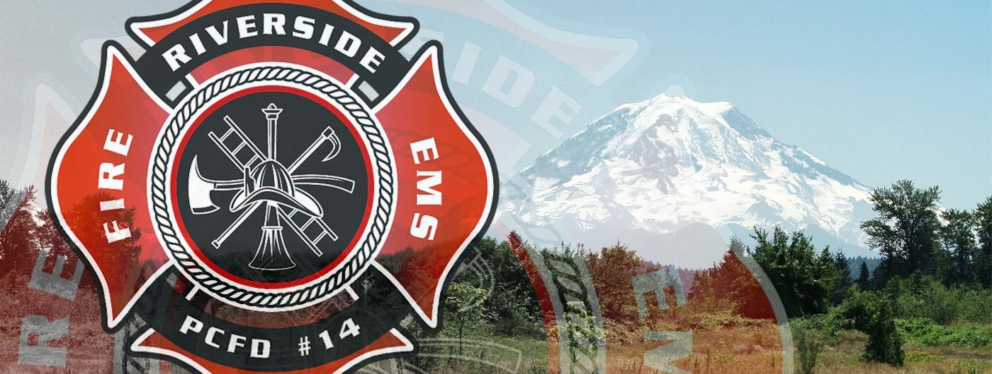

Commitment – “the state or quality of being dedicated to a cause, activity, etc.”

When you sign this form you commit yourself to uphold the Mission Statement, Vision and Core Values of the Department.

Commitment means –

1. Commitment to your Craft: Firefighting and EMS is a very special craft that takes years and years to master just the basic concepts. NEVER STOP LEARNING!! Commit yourself to learning everything you can about this craft, whether that’s “The Art of Reading Smoke” or “Nozzle Forward (The Art of Fighting Fire)”. Always stay up to date on current protocols, treatments and skills. IT IS NEVER TIME TO LEARN WHEN THE TONES GO OFF!!!

2. Commitment to your Community: There is ONE reason you got into this job, and that reason can be defined in one word…PEOPLE! You are here to serve the people in the community this fire district covers! Never forget that! We ARE NOT here to wear a cool badge! We ARE NOT here to ride on a cool fire truck! By joining this or any organization in the future, you are making an unbreakable vow that you will do everything in your power to protect the people in your community.

3. Commitment to your Organization: Be prideful in your organization! Keep the vehicles in pristine condition. Keep the equipment in tip top shape. If there is a chance to be involved in a public education opportunity, be the first to sign up! What you put into this career, is what you will get out of it!

4. Commitment to your Team: If you dedicate yourself to the above commitments, this one will naturally fall into place. By committing yourself to mastering your craft, you will never leave your teammates in a dangerous situation and will always have their backs. By committing yourself to the community, you will do everything in your power to protect it which will in turn promote your teammates to do the same. By committing yourself to your organization you will maintain our equipment and apparatus showing pride and respect in all that you have earned.

Recruit Signature

